Garbage separation is stipulated as the citizens’ responsibility in the ordinance. Garbage bag(s) including inappropriate items will not be collected.
~

。異物を混入させないでください。
A Guide to Garbage Disposal for Residents of（物件名）

Type of Waste | Examples | Collection Day | How to Sort and Discard Waste | Collection Point
Cans | 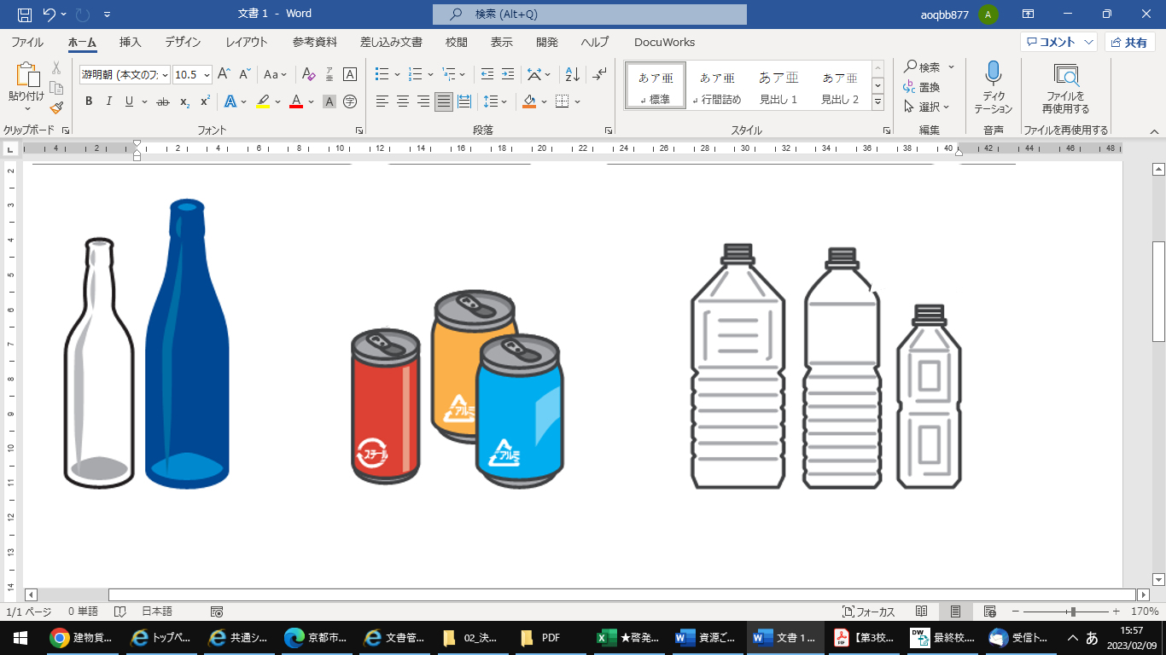  Food and beverage cans  (18 litter drums should be discard as “Oversized Garbage.”）
Ｇlass Bottles | 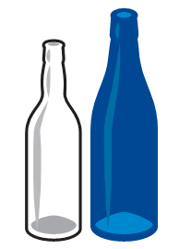  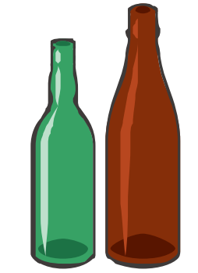  Unbroken glass bottles and food jars  (excluding tops and lids)
Plastic Bottles  （PET) | 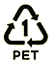  PET bottles  (Caps and labels should be discarded as “Plastics.”)
Plastics  （Plastic products, plastic containers and packaging) | Plastic items with the maximum length less than 50 cm  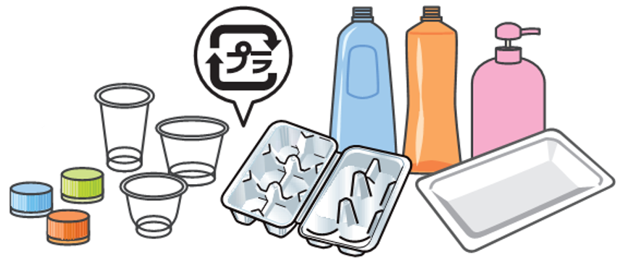  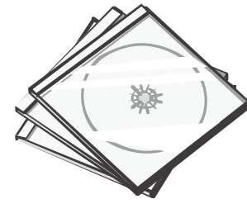    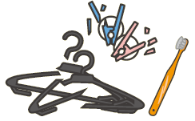  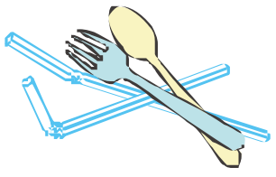  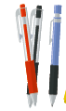    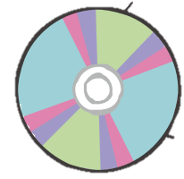  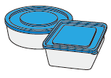  (Larger items should be discarded as “Oversized Garbage.” )  Plastic products  Plastic containers and packaging
Recyclable Paper | 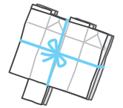  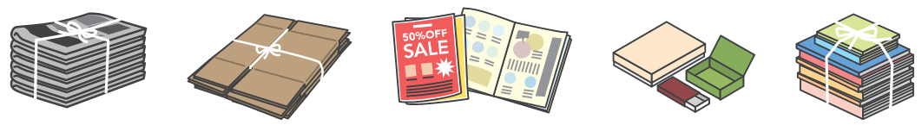  Newspapers, cardboard, miscellaneous paper waste, and cartons
Small Metal Items  & Spray Cans | 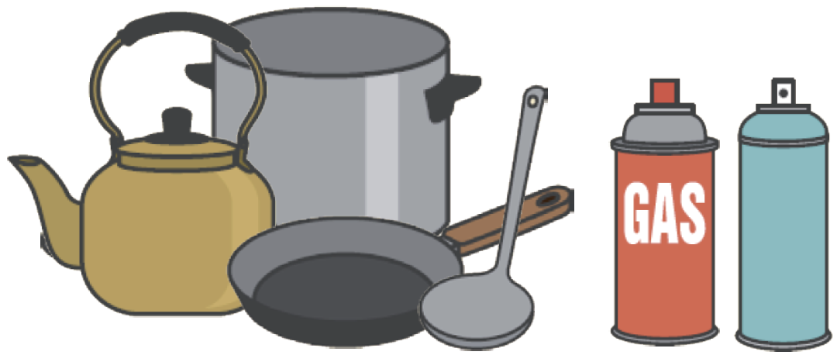  Pots, kettles and other metal items with the maximum length of 30cm or less（excluding the handle),  and spray cans  (Larger items should be discarded as  “Oversized Garbage.”)
Burnable Garbage | 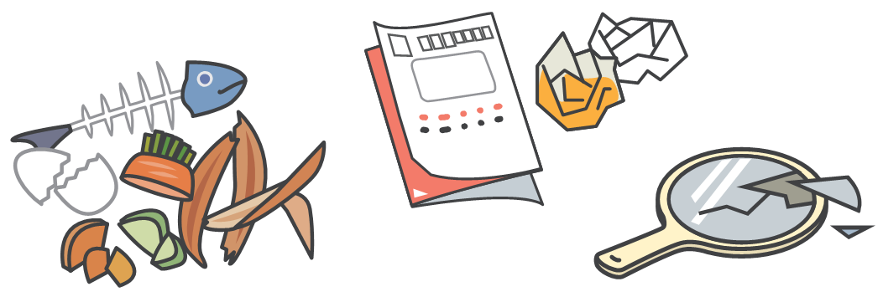  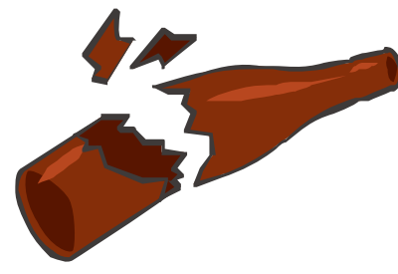  Kitchen refuse,  non-recyclable paper waste,  broken glass, etc.
Oversized Garbage  *If items are still in good condition, give them to the others to “reuse” them. | 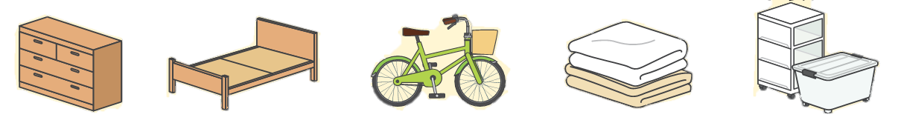  Furniture, home appliance（excluding TVs, refrigerators/ freezers, air conditioners, washers and clothes dryers, PCs）, etc.

