Garbage separation is stipulated as the citizens’ responsibility in the ordinance. Garbage bag(s) including inappropriate items will not be collected.
~

。異物を混入させないでください。
Guide to Garbage Disposal for Residents of（物件名）

Type of Waste | Examples | Collection Day | How to Sort and Discard Waste | Collection Point
Cans | 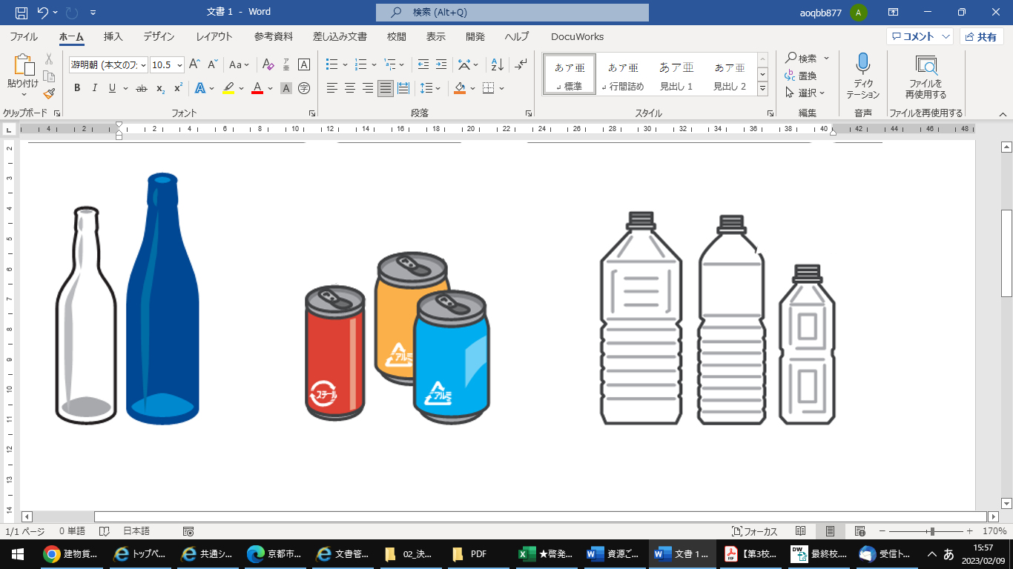  Food and beverage cans  (18 liter drums should be discarded as “Oversized Garbage.”） |  | ・Use the city’s designated transparent bag(s) for recyclables.  ・Empty cans or bottles and rinse inside.  ・Remove tops, lids and labels. Do not crush them.  ・Put cans, glass bottles, jars and PET bottles together in the same bag. | Designated “Recyclables” collection point  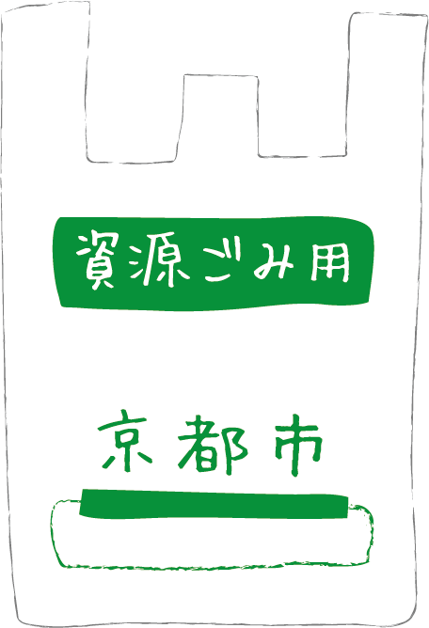  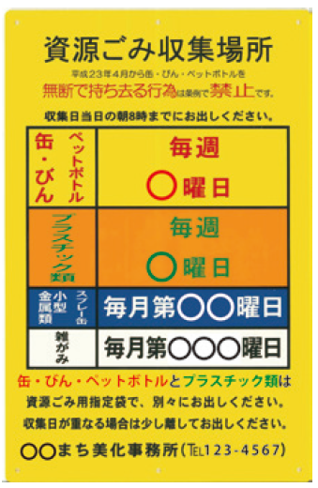
Ｇlass Bottles | 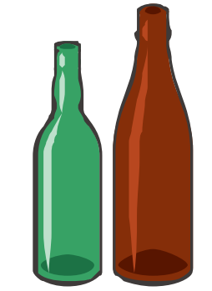  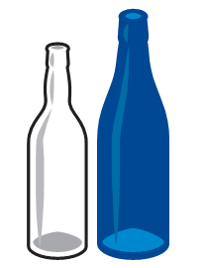  Unbroken glass bottles and food jars  (excluding tops and lids)
Plastic Bottles  （PET) | 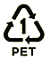  PET bottles  (Caps and labels should be discarded as “Plastics.”)
Plastics  (Plastic products, plastic containers and packaging) | Plastic items with the maximum length less than 50 cm  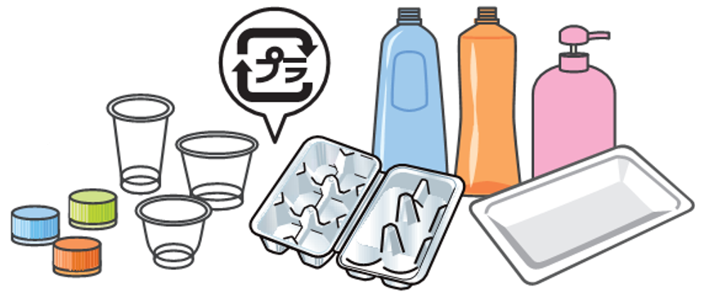  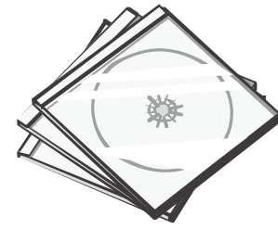    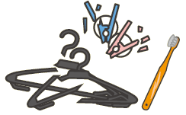  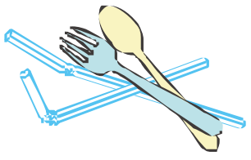  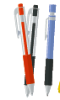    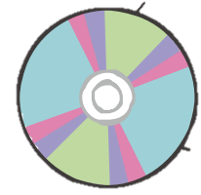  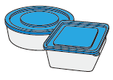  (Larger items should be discarded as “Oversized Garbage.” )  Plastic products  Plastic containers and packaging |  | ・Use the city’s designated transparent bag(s) for recyclables.  ・Empty the contents and remove stains before discarding.  ・Do not put any irrelevant items such as electric or battery-powered items, batteries, lighters, edged tools, and items with needles in a garbage bag.  (Take them to a collection point at the designated public facilities instead.) | Designated “Recyclables” collection point
Recyclable Paper | Newspapers, cardboard, miscellaneous paper waste, and cartons  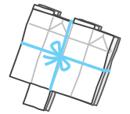  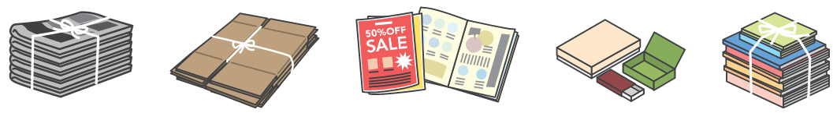 |  | ・Fold paper items and tie them up with string to prevent scattering, or put them in a paper bag or a colorless or white translucent bag. | Designated collection point at the designated public facilities
Small Metal Items  & Spray Cans | Pots, kettles and other metal items with the maximum length of 30 cm or less (excluding the handle), and spray cans  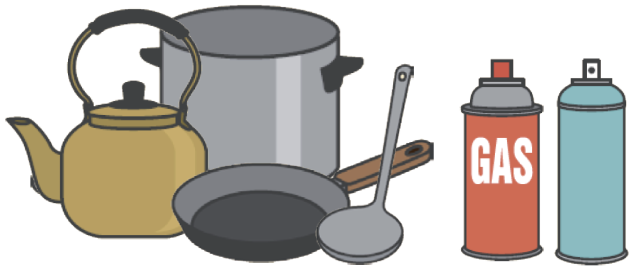  (Larger items should be discarded as “Oversized Garbage.”) |  | ・Use strong colorless or white translucent bag(s) and write “金属(Metal)” on them.  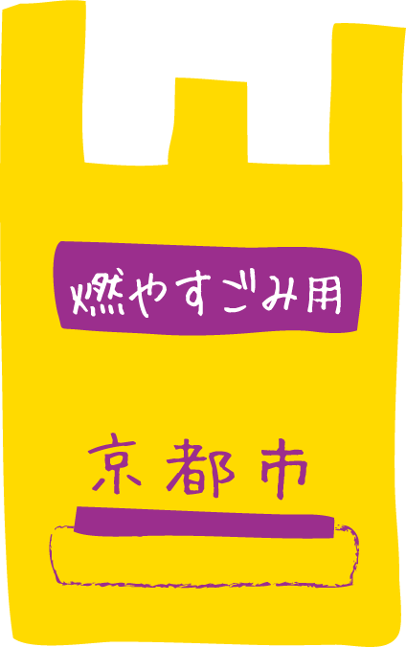  ・Remove stains before discarding. Use up the contents of spray cans and cassette gas cylinders and dispose of them without puncturing them. | Designated “Recyclables” collection point  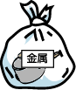
Burnable Garbage | 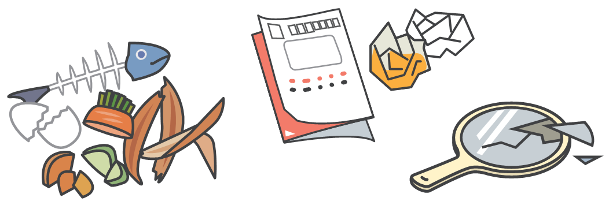  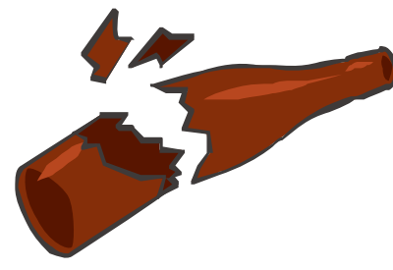  Kitchen refuse, non-recyclable paper waste, broken glass, etc. |  | ・Use the city’s designated yellow bag(s)  for combustible garbage.  ・Wrap sharp items such as broken glass with thick paper and place it in the middle of a garbage bag. | Designated “Burnable Garbage” collection point  Cover garbage bag(s) completely with  the garbage net.
Oversized Garbage  *If items are still in good condition, give them to the others to “reuse” them. | 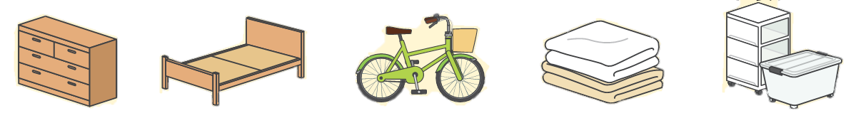  Furniture, home appliance（excluding TVs, refrigerators/ freezers, air conditioners, washers and clothes dryers, PCs）, etc. | On Request | ・Do not crush nor dismantle.  ・Request the Kyoto City Oversized Garbage Collection Center to collect the items or take them to the city’s incineration plant by yourself. | Put the items outside, but do not to block the others’ traffic.

